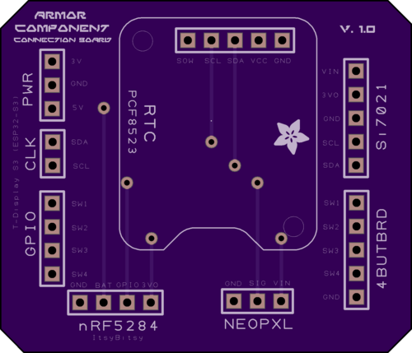

Board Top
This shows the final manufactured board as if you held it in your hand.
Your design should show gold copper, purple mask, white silk, black drills, and the board outline.
Internal cutouts are indicated by a black outline but are not filled in.
If the image here is entirely white, you'll want to find and fix any gaps in the board outline.
There should be no dimension or measurement ruler
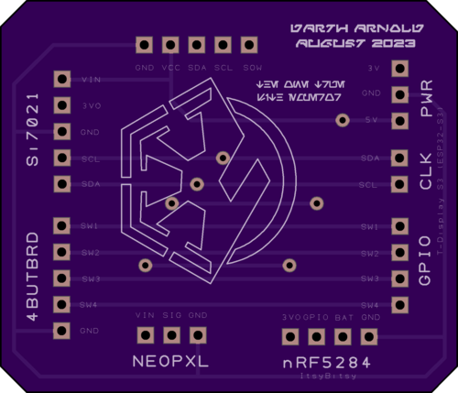

Board Bottom
This shows the final manufactured board as if you held it in your hand.
Your design should show gold copper, purple mask, white silk, black drills, and the board outline.
Internal cutouts are indicated by a black outline but are not filled in.
If the image here is entirely white, you'll want to find and fix any gaps in the board outline.
There should be no dimension or measurement ruler
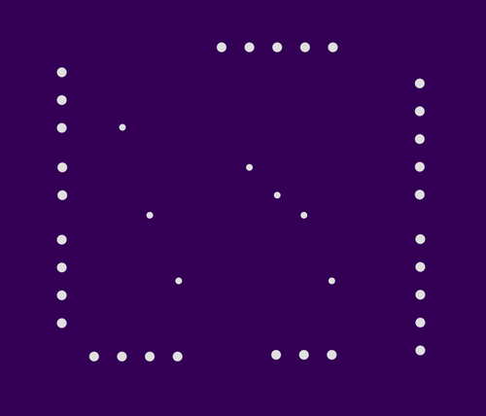
Rendered from "Bracer Junction - NC Drill Data - [Through Hole].drl"

Drills
Drills should show up as white circles or dots on a purple background.
Drill files should be NC Drill or Excellon format files. Multiple files will be accepted, and merged into one for fabrication.
Drill hits that pass through copper will be plated. All other drill hits will be non-plated.
Most drill formats are detected and displayed as you'd see on the board. If your drills look incorrect, try exporting with INCH units and either No Zero Suppression or Leading Zero Suppression.
Drill slots and "oval" drills included as part of the drill file are supported. Most design tools do this when using the tool's native slot commands. Supported slots will appear on this preview.
Note, it's possible to use this supported callout in an unsupported way. See our Cutouts and Slots page for details regarding unsupported applications of slot drill commands.
Drills sizes below our minimums will be increased to the minimum size. See the design rules or our drills help page. for additional details on drill specs.
Additionally, the following are not supported.
- Overlapping drill hits
- Blind or buried vias
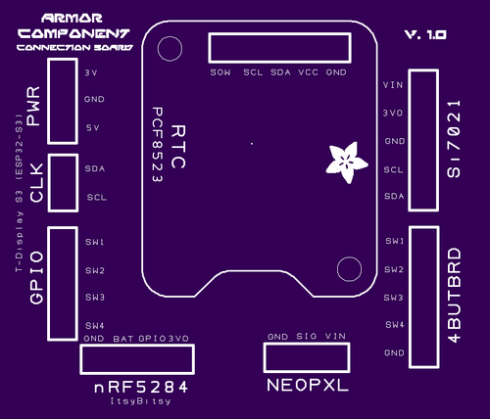
Rendered from "Bracer Junction - Top Silkscreen.gbr"

Top Silk Screen
We will ignore the portion of the silkscreen that extends beyond the board outline.
We will automatically remove any silkscreen that crosses drilled holes or exposed copper.
If a logo isn't showing up on this layer, try changing your design tool import settings to create that silk image with 400 DPI or less, or check out our Eagle-specific import-bmp script instructions.
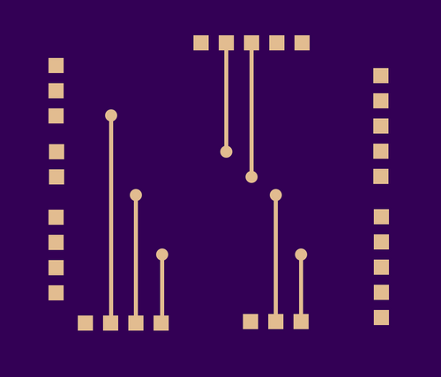
Rendered from "Bracer Junction - Top Copper.gbr"

Top Layer
We will place copper everywhere we see gold color on this layer.
If you are using Altium Designer or Altium CircuitMaker, carefully examine the board to make sure there are no shorts from the mechanical layers being included on this layer. See here for more.
If you are using Eagle, be aware that airwires are not the same as routed traces. If there are no copper links between pads showing on this layer, please review your .brd file for airwires.
See our design tools pages for more.
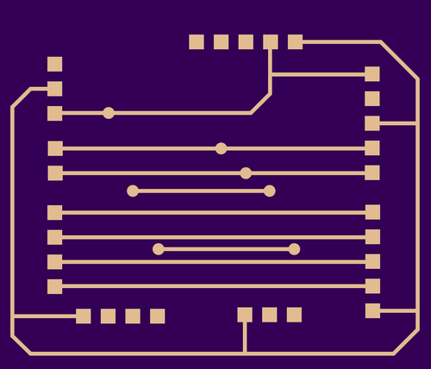
Rendered from "Bracer Junction - Bottom Copper.gbr"

Bottom Layer
This layer should appear 'mirrored' as if you were looking down on it through the board from the top.
We will place copper everywhere we see gold color on this layer.
If you are using Altium Designer or Altium CircuitMaker, carefully examine the board to make sure there are no shorts from the mechanical layers being included on this layer. See here for more.
If you are using Eagle, be aware that airwires are not the same as routed traces. If there are no copper links between pads showing on this layer, please review your .brd file for airwires.
See our design tools pages for more.
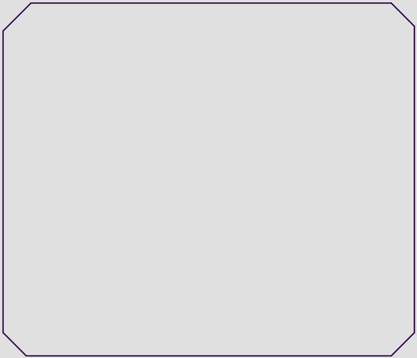
Rendered from "Bracer Junction - Board Outline.gbr"

Board Outline
The board outline should be a watertight purple outline showing at least the edge of the board with no gaps.
We will cut non-rectangular board shapes, but you will be billed for the smallest rectangle that will encompass the design.
As an example, a 2in diameter circle is billed the same as a 2in by 2in square.
Non-plated Board Cutouts can be represented on the board outline layer, with some limitations.
Slots are unsupported when indicated on the board outline layer, but usually work. To make slots with full support, use Drill Slots on the drill layer.
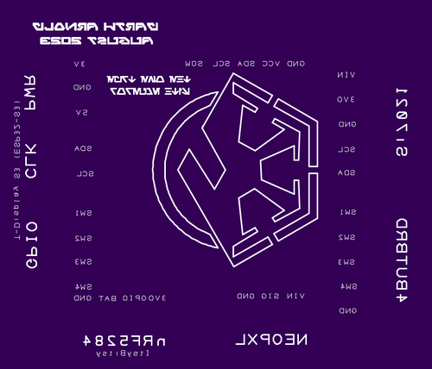
Rendered from "Bracer Junction - Bottom Silkscreen.gbr"

Bottom Silk Screen
This layer should appear 'mirrored' as if you were looking down on it through the board from the top.
We will ignore the portion of the silkscreen that extends beyond the board outline.
We will automatically remove any silkscreen that crosses drilled holes or exposed copper.
If a logo isn't showing up on this layer, try changing your design tool import settings to create that silk image with 400 DPI or less, or check out our Eagle-specific import-bmp script instructions.
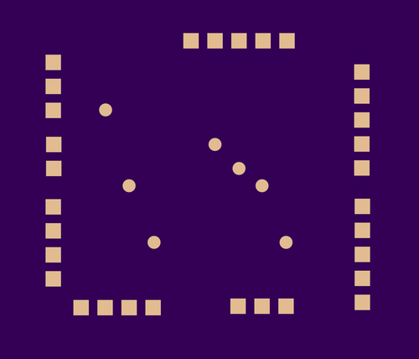
Rendered from "Bracer Junction - Bottom Solder Mask.gbr"

Bottom Solder Mask
This layer should appear 'mirrored' as if you were looking down on it through the board from the top.
Soldermask layers show us where to remove the purple solder resist. The gold-colored areas will be exposed on the final board, and purple areas will be covered.
If you submitted an empty file, we won't remove any mask so this entire side of the board will be covered in purple soldermask
To expose the entire board, submit this file with a single polygon that covers the entire board. We will remove all mask everywhere and expose all the copper and board substrate.
Rendered from "Bracer Junction - Top Solder Mask.gbr"

Top Solder Mask
Soldermask layers show us where to remove the purple solder resist. The gold-colored areas will be exposed on the final board, and purple areas will be covered.
If you submitted an empty file, we won't remove any mask so this entire side of the board will be covered in purple soldermask
To expose the entire board, submit this file with a single polygon that covers the entire board. We will remove all mask everywhere and expose all the copper and board substrate.

